NORTHUMBERLAND DISTRICT ATV RIDERS CLUB 2019 CALENDAR OF EVENTS
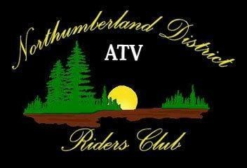
Please notify the club at ndatv@northumberlandatvriders.com at least 1 week prior to any event to let us know you will be attending
All events and rides will be held at the NDATV CLUBHOUSE unless specified.
The NDATV CLUBHOUSE is located at 505 McDonald Road in Centreton
Date | Event
April 20th, 2019 | Ride to Campbellford for lunch. Leave from the Clubhouse. Meet at 10 am, leave at 11 am** Due to inclement weather we have moved this ride to May 5th.**
May 15th, 2019 | Northumberland Forest Open for ATVs.
May 18th, 2019 | Ride through the forest. Meet at the clubhouse at 10, leave at 11.
June 15th, 2019 | General Membership Meeting& BBQ and Ride afterwards. Registration at 9 am, Meeting at 10 am, ride afterwards. No charge for NDATV Club members/$10 per nonmembers.
August 17, 2019 | Corn roast camping weekend Cost: 5$; Ride on Saturday (TBD)  Potluck Breakfast Sunday for Campers
September 7th, 2019 | Overnight Camping Trip, details TBD.
September 28th, 2019 | WFD Fundraiser Meeting location to be determined.
October 19th, 2019 | Fall Colours Ride details TBD
November 2, 2019 | Saturday General Membership Meeting & Ride  Toy Drive - All riders to bring a new unwrapped toy for a child or teen to be donated at Christmas
December 28, 2019 | Annual Year End Ride and Dinner.  $5.00 NDATV Club Member/$10.00 nonmembers. Location to be Determined.

NOTE: | We have two free BBQ's this year with our General Membership Meetings. Please bring your own food and refreshments for all other rides.  The calendar and the website's main page will be updated with the most current information concerning the upcoming event or ride.  Please check the website frequently.

