NORTHUMBERLAND DISTRICT ATV RIDERS CLUB 2020 CALENDAR OF EVENTS
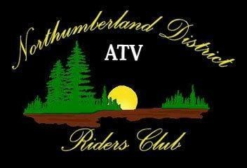
Please notify the club at ndatv@northumberlandatvriders.com at least 1 week prior to any event to let us know you will be attending
All events and rides will be held at the NDATV CLUBHOUSE unless specified.
The NDATV CLUBHOUSE is located at 505 McDonald Road in Centreton
Date | Event
April 11th, 2020 | *Trail maintenance crew* Bridge work day -postponed
April 18th, 2020 | NDATV ride TBD -postponed
May 15th, 2020 | Northumberland Forest closed until further notice
May 17th, 2020 | NDATV General Membership meeting & BBQ. Ride through the forest afterwards. Meet at the clubhouse at 9 AM. -postponed
May 23rd, 2020 | CF Moto Demo Day at the Clubhouse! Hosted by R & R Trail Motor Sports. Time to be determined. -postponed
June 20th, 2020 | NDATV All DAY ride. Meet at the clubhouse at 7 am for registration. Bring gas can. -postponed
July 4th, 2020 | Farmtown museum tour and ride. -postponed
July 17th, 2020 | BBQ camping weekend -postponed -Ride on Saturday (TBD)
August 1st, 2020 | Overnight Camping Trip-postponed. Club ride (TBD)
September 26th, 2020 | Warkworth Fire Department ride (TBD)
October 18th, 2020 | Saturday General Membership Meeting & Ride  Toy Drive - All riders to bring a new unwrapped toy for a child or teen to be donated at Christmas.
November 21, 2020 | Farmtown Christmas Ride (2nd chance to bring a new unwrapped toy for a child or teen to be donated at Christmas)
November ??^{th}, 2020 | Colborne & Brighton parades. Dates to be determined. Come join us and ride in the parade!
December 27, 2020 | Annual Year End Ride and Dinner.  $5.00 NDATV Club Member/$10.00 nonmembers. Location to be Determined.

NOTE: | We have two free BBQ's this year with our General Membership Meetings. Please bring your own food and refreshments for all other rides.  Facebook will be updated with the most current information concerning the upcoming event or ride. Please check our page frequently.

